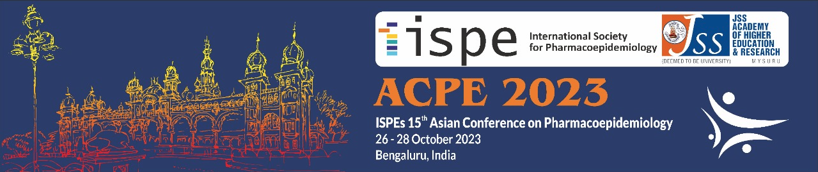

ACPE15 SYMPOSIA APPLICATION FORM

Expressions of interest are sought for symposia to be presented at ISPE’s 15th Asian Conference on Pharmacoepidemiology to be held from 26—28 October 2023 at Sheraton Grand Bangalore Hotel at Brigade Gateway, Bangalore, India.

ISPE-ACPE15, will be a face-to-face meeting.

Educational sessions will be delivered on Friday 26 October and Symposia will be scheduled on Saturday 27 and Sunday 28 October.

Please complete all details below and submit this application form as a WORD document via the online portal at https://expertevents.eventsair.com/acpe-2023/symposium-submission

If you have any questions or problems, please contact Expert Events at acpe@expertevents.com.au

Submission deadline: Friday 9 June 2023
Notification of acceptances/regrets: Friday 14 July 2023

Symposium applicant details:
Name:
Affiliation:
Address:
Phone: |  | Email address:

Semi-structured abstract:
Symposium title:
Background/ problem being addressed:
Approach:
Learning objective/s:

Why is this topic of interest to ISPE’s membership, particularly in the Asian region?

Proposed speakers:
- Name:
Position title:
Affiliation:
Country:
Email address:
In-person only
- Name:
Position title:
Affiliation:
Country:
Email address:
In-person only
- Name:
Position title:
Affiliation:
Country:
Email address:
In-person only

- Name:
Position title:
Affiliation:
Country:
Email address:
In-person only
- Name:
Position title:
Affiliation:
Country:
Email address:
In-person only

- Name:
Position title:
Affiliation:
Country:
Email address:
In-person only

Proposed moderator (in-person only):
Name:
Position title:
Affiliation:
Country:
Email address:

